Final Exam

Biying Wan 15620161152279

HW1

**1.1 Calculate the increase of memory of PCs over the last 30 years and check whether the FMRI analysis could have been done 20 years ago**

|  |  |  |  |
| --- | --- | --- | --- |
| Development of memory | | Time | Capacity |
| No memory bank | | before 286 | 64KB-256KB |
| FPM DRAM | 30pin SIMM | 1982 | 256KB |
| 72pin SIMM | 1988-1990 | 512KB-2MB |
| EDO DRAM | | 1991-1995 | 4MB-16MB |
| SDR SDRAM | PC66/100/133/150/166 | 1996-1999 | 16MB-512MB |
| Rambus DRAM | PC600/PC700/PC800 | 1997-2002 | 64MB-512MB |
| DDR SDRAM | DDR | 2002 | 128M-1GB |
| DDR2 | 2004 | 256MB-4GB |
| DDR3 | 2007 | 512MB-8GB |
| DDR4 | 2014 | 4GB-16GB |

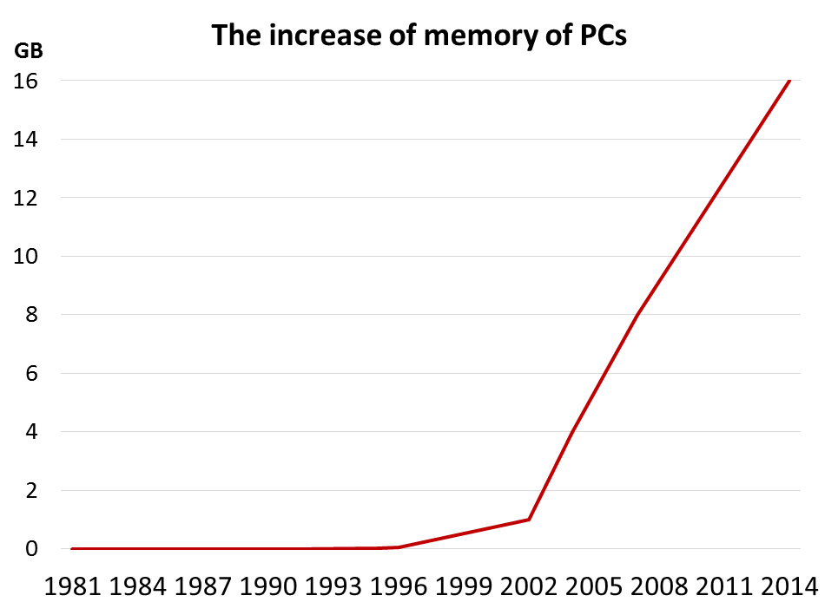

**1.2 prepare 2-5 slides explaining logistic regression**

* Logistic Regression - Dichotomous Response variable and numeric and/or categorical explanatory variable(s)
  + Goal: Model the probability of a particular as a function of the predictor variable(s)
  + Problem: Probabilities are bounded between 0 and 1
* Distribution of Responses: Binomial
* Link Function: $g(μ)=log\left(\frac{μ}{1-μ}\right)$
* Response - Presence/Absence of characteristic
* Predictor - Numeric variable observed for each case
* Model - *p*(*x*) ≡ Probability of presence at predictor level *x*
$π(x)=\frac{e^{α+βx}}{1+e^{α+βx}}$

* $β$ = 0 ⇒ P(Presence) is the same at each level of *x*
* $β$ > 0 ⇒ P(Presence) increases as *x* increases
* $β$ < 0 ⇒ P(Presence) decreases as *x* increases
* $α$*, $β$*  are unknown parameters and must be estimated using statistical software such as SPSS, SAS, or STATA
* Primary interest in estimating and testing hypotheses regarding *b*
* Large-Sample test (Wald Test):
* *H*0: = 0 *H*A: ≠

HW2

**2.1 make an R quantlet to solve HW #1 from unit 1 with R and show it on Github (GH)**

**hint: use the CMB Qs for this work**

year<-c(1981,1982,1988,1990,1991,1995,1997,1999,2000,2001,2002,2004,2007,2014)

capacity<-c(6.10352E-05,0.000244141,0.000488281,0.001953125,0.00390625,0.015625,0.0625,0.125,0.25,0.5,1,4,8,16)

plot(year,capacity,type = "b",main = "The increase memory of PCs",xlab = "year",ylab = "memory")

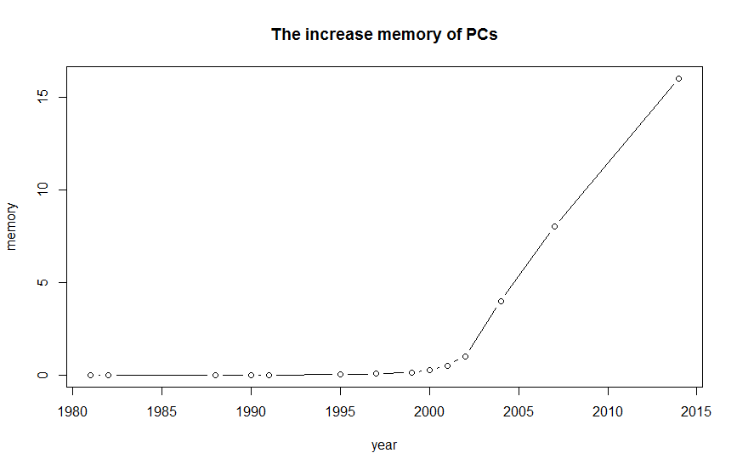

**2.2 use R with B-spline code to solve HW#1, any comments?**

year<-c(1981,1982,1988,1990,1991,1995,1997,1999,2000,2001,2002,2004,2007,2014)

capacity<-c(6.10352E-05,0.000244141,0.000488281,0.001953125,0.00390625,0.015625,0.0625,0.125,0.25,0.5,1,4,8,16)

library(splines)

plot(year,capacity)

lines(spline(year,capacity))

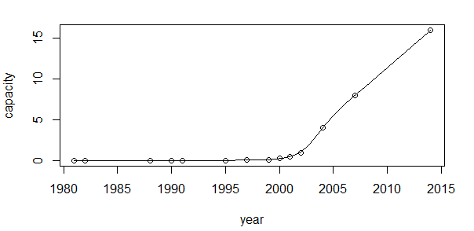

**2.3 Suppose you observe that in n=1000 mails (in 1 week) you have about 2 scams. Use the**

**LvB /Poisson cdf to calculate that you have 6 scam emails in 2 weeks. In Scammyland**

**you have 5 scams on average, what is the probability to have no scam mail.**

（1）LvB PDF:

dbinom(x = 6,size = 2000,prob =2/1000)

[1] 0.1042477

With LvB PDF, the probability is 0.104.

（2）Possion PDF:

dpois(x = 0,lambda = 5)

[1] 0.006737947

With Possion PDF, the probability is 0.00674.

HW3

**3.1 make an R quantlet on GH to produce hash code for the 2 sentences: “I learn a lot from this class when I am proper listening to the professor”, “I do not learn a lot from this class when I am absent and playing on my Iphone”. Compare the 2 hash sequences**

* install.packages("digest")
* library("digest")
* digest("I learn a lot from this class when I am proper listening to the professor","sha256")
* [1]"c16700de5a5c1961e279135f2be7dcf9c187cb6b21ac8032308c715e1ce9964c"
* digest("I do not learn a lot from this class when I am absent and playing on my Iphone","sha256")
* [1]"2533d529768409d1c09d50451d9125fdbaa6e5fd4efdeb45c04e3c68bcb3a63e"

**3.2 Make 3-5 slides (in PPTX) on the DSA (Digital Signature Algorithms)**

* A **digital signature** is basically a way to ensure that an electronic document (e-mail, spreadsheet, text file, etc.) is **authentic**. Digital signatures are used to verify that a message or document was authored by a certain person, and that it was not altered or modified by anyone else.
* One of the most common digital signature mechanisms is DSA. The **Digital Signature Algorithm (DSA)** is the basis of the **Digital Signature Standard (DSS)**, a U.S. Government document.
* DSA lets one person with a secret key “sign” a document, so that others with a matching public key can verify it must have been signed only by the holder of the secret key.
* Digital signatures depend on **hash functions**, which are one-way computations done on a message. They are called “one-way” because there is no known way (without infeasible amounts of computation) to find a message with a given hash value. The result has a fixed length, which is 160 bits in the case of the Secure Hash Algorithm (SHA) used by DSA.
* In practice, digital signatures are used to sign the hash values of messages, not the messages themselves. Thus it is possible to sign a message’s hash value, without even knowing the content of the message. This makes it possible to have *digital notaries*, who can verify a document existed (and was signed), without the notary knowing anything about what was in the document.

**3.3 Make slides with R code where you create a JSON data set that you save and read again.**

* install.packages("rjson")
* library("rjson")
* json_file3="D:/研二/研二上/大数据与互联网金融/HW3/test.json"
* json_data3<- fromJSON(paste(readLines(json_file3), collapse=""))
* json_data3<- as.data.frame(json_data3)
* print(json_data3)



**3.4 Download the CRIX data and make a plot of the time series, analyse its properties, i.e.**

**fit ARMA, ARIMA etc. Is there a GARCH effect?**

* install.packages("ggplot2")
* install.packages("scales")
* library("rjson")
* json_file="D:/研二/研二上/大数据与互联网金融/HW3/crix.json"
* json_data <- fromJSON(paste(readLines(json_file), collapse=""))
* json_df <- as.data.frame(c(json_data[[1]][1],json_data[[1]][2]))
* for (i in 2:length(json_data)){
* json_df <- rbind(json_df,as.data.frame(c(json_data[[i]][1],json_data[[i]][2])))
* }
* json_df$date <- as.POSIXct(json_df$date)
* library(ggplot2)
* library(scales)
* ggplot(json_df)+
* geom_line(aes(x=date,y=price))+
* scale_x_datetime(breaks=date_breaks("6 month"),labels=date_format("%Y/%m"))

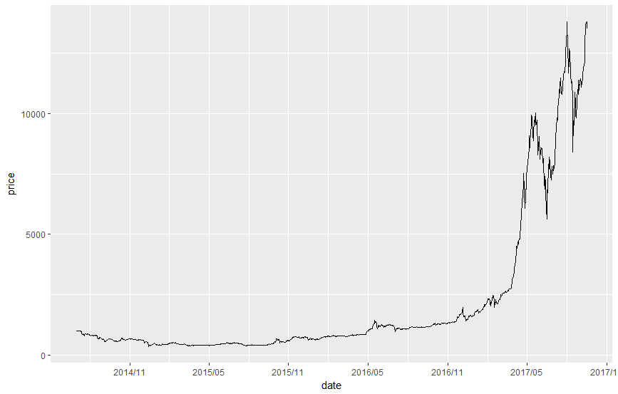

* x<-json_df[,2]
* return<-log(x[2:nrow(json_df)])-log(x[1:nrow(json_df)-1])
* return<-c(NA,return)
* json_return<-as.data.frame(cbind(json_df,return))
* json_return<-json_return[,-2]
* plot(json_return,type="l")

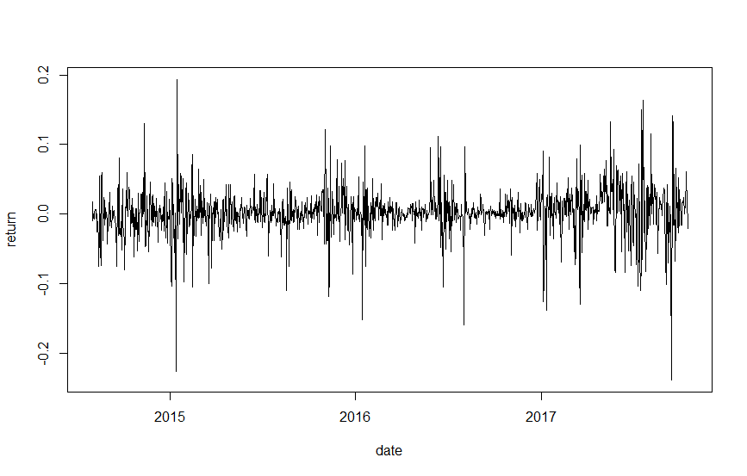

* hist(json_return$return,freq=FALSE,breaks=12,col="red",xlab="return",main="Density Histogram")

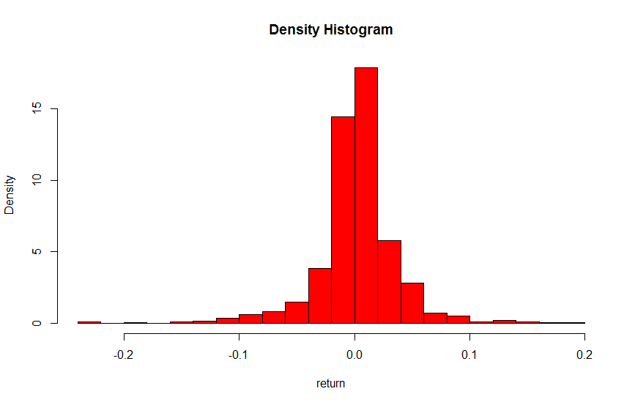

* qqnorm(json_return$return)

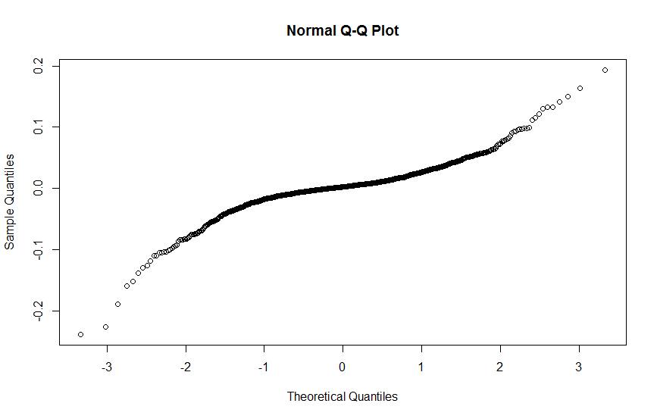

Therefore, CRIX returns is not normally distributed.

HW 4

**4.1 improve the R quantlets on GH (from CRIX directory on quantlet.de) and make excellent graphics that follow Fig 3,4,5,6 of the “Econometrics of CRIX” paper.**

#download data

#price

library("rjson")

#json_file="D:/研二/研二上/大数据与互联网金融/HW4/crix.json"

json_file="http://crix.hu-berlin.de/data/crix.json"

json_data <- fromJSON(paste(readLines(json_file), collapse=""))

json_df <- as.data.frame(c(json_data[[1]][1],json_data[[1]][2]))

for (i in 2:length(json_data)){

json_df <- rbind(json_df,as.data.frame(c(json_data[[i]][1],json_data[[i]][2])))

}

json_df$date <- as.POSIXct(json_df$date)

# return

x<-json_df[,2]

return<-log(x[2:nrow(json_df)])-log(x[1:nrow(json_df)-1])

return<-c(NA,return)

json_return<-as.data.frame(cbind(json_df,return))

json_return<-json_return[-1,-2]

#save dataset

save(json_df,file="D:/研二/研二上/大数据与互联网金融/HW4/crix.RData")

save(json_return,file="D:/研二/研二上/大数据与互联网金融/HW4/return.RData")

#clear

rm(list = ls(all = TRUE)) #rm(list = ls())

graphics.off()

# install and load packages

libraries = c("zoo", "tseries", "xts")

lapply(libraries, function(x) if (!(x %in% installed.packages())) {

install.packages(x)

})

lapply(libraries, library, quietly = TRUE, character.only = TRUE)

#load dataset

load(file = "D:/研二/研二上/大数据与互联网金融/HW4/crix.RData")

load(file = "D:/研二/研二上/大数据与互联网金融/HW4/return.RData")

#fig 3 in Econometrics of CRIX, plot of crix

#plot(json_df,xlab=NA,ylab=NA,type="l",col="red")

library(ggplot2)

library(scales)

ggplot(json_df)+

geom_line(aes(x=date,y=price))+

scale_x_datetime(breaks=date_breaks(“4 month"),labels=date_format("%Y/%m"))

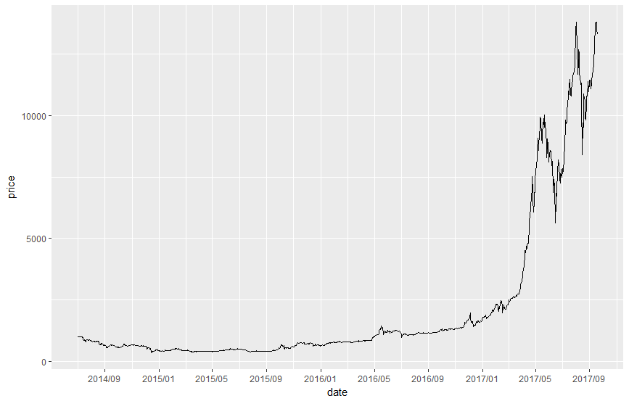

Figure 1 The daily value of CRIX index from 01/08/2014 to 19/10/2017

#fig 4 in Econometrics of CRIX ,plot of return

#plot(json_return,xlab=NA,ylab=NA,type="l")

ggplot(json_return)+

geom_line(aes(x=date,y=return))+

scale_x_datetime(breaks=date_breaks("4 month"),labels=date_format("%Y/%m"))

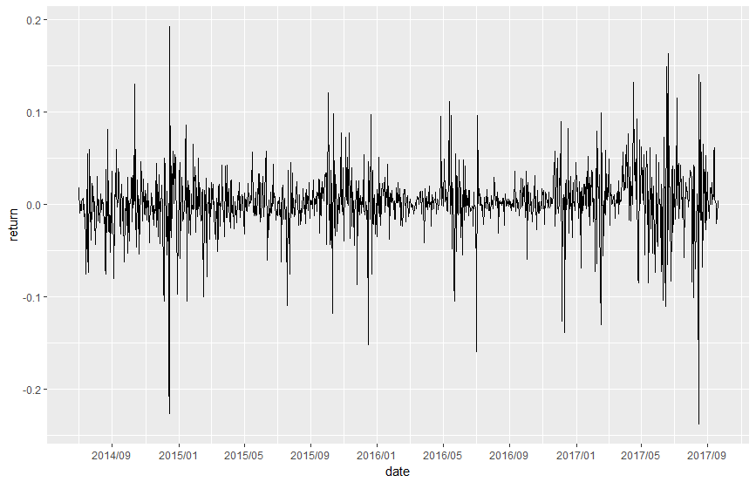

Figure 2 The log returns of CRIX index from 01/08/2014 to 19/10/2017

#fig 5 in Econometrics of CRIX,histogram of returns,qq-plot

return<-json_return[,2]

par(mfrow = c(1, 2))

# histogram of returns

hist(return, col = "grey", breaks = 20, freq = FALSE, ylim = c(0, 25), xlab = "return")

lines(density(return), lwd = 2)

mu = mean(return)

sigma = sd(return)

x = seq(-4, 4, length = 100)

curve(dnorm(x, mu, sigma), add = TRUE, col = "darkblue", lwd = 2)

# qq-plot

qqnorm(return)

qqline(return, col = "blue", lwd = 3)

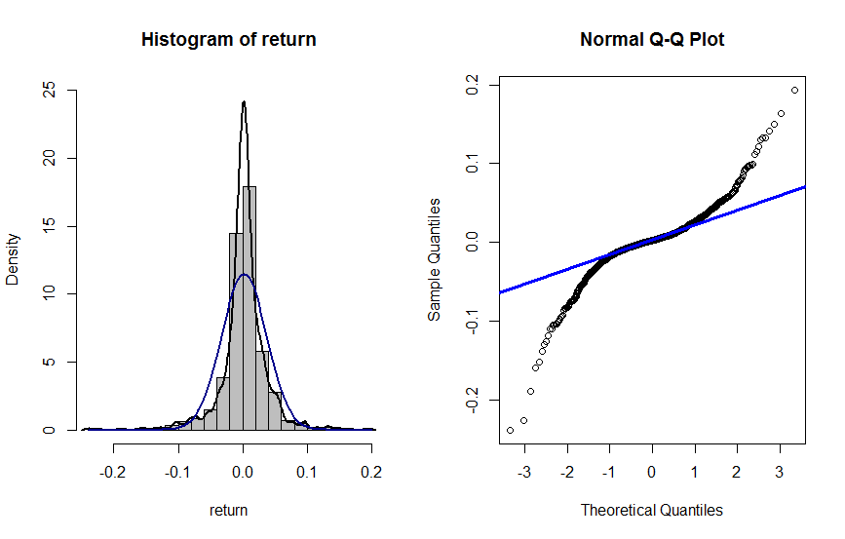

Figure 3 Histogram and QQ plot of CRIX returns from 01/08/2014 to 19/10/2017

#fig 6 in Econometrics of CRIX

par(mfrow = c(1, 2))

# acf plot

autocorr = acf(return, lag.max = 20, ylab = "Sample Autocorrelation", main = NA, lwd = 2, ylim = c(-0.3, 1))

# pacf plot

autopcorr = pacf(return, lag.max = 20, ylab = "Sample Partial Autocorrelation", main = NA, ylim = c(-0.3, 0.3), lwd = 2)

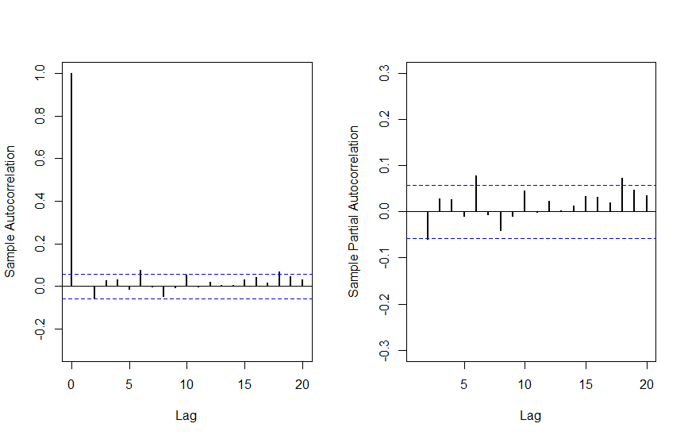

Figure 4 The sample ACF and PACF of CRIX returns from 01/08/2014 to 19/10/2017

**4.2 make your R code perfect as in the R examples on quantlet.de i.e. make sure that the code is “time independent” by using actual dimensions of the data that you are collecting from crix.hu-berlin.de Recreate Fig 7 from “Econometrics of CRIX”.**

#fig 7 in Econometrics of CRIX, arima202 predict

graphics.off()

fit202 = arima(return, order = c(2, 0, 2))

crpre = predict(fit202, n.ahead = 30)

dates = seq(as.Date("01/08/2014", format = "%d/%m/%Y"), by = "days", length = length(return))

plot(return, type = "l", xlim = c(0, 1206), ylab = "return", xlab = "days", lwd = 1.5)

lines(crpre$pred, col = "red", lwd = 3)

lines(crpre$pred + 2 * crpre$se, col = "red", lty = 3, lwd = 3)

lines(crpre$pred - 2 * crpre$se, col = "red", lty = 3, lwd = 3)

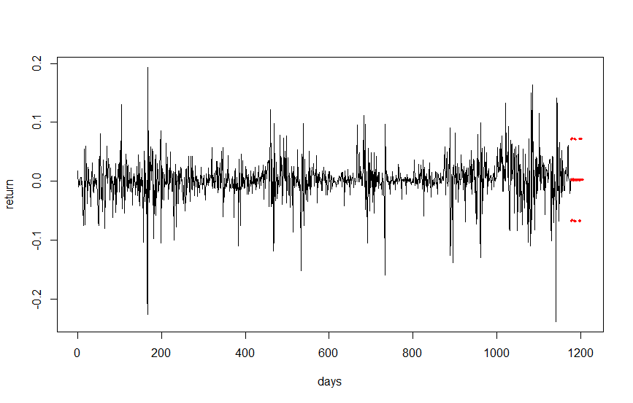

Figure 5 CRIX returns and predicted values

**4.3 redo as many figures as you can.**

# fig 8 in Econometrics of CRIX, Volatility cluster

graphics.off()

date=json_return$date

Volatility= fit202$residuals^2

tsres202 = data.frame(date,Volatility)

#plot(tsres202, type = "l",xlab="date", ylab = "Volatility")

ggplot(tsres202)+

geom_line(aes(x=date,y=Volatility))+

scale_x_datetime(breaks=date_breaks("4 month"),labels=date_format("%Y/%m"))

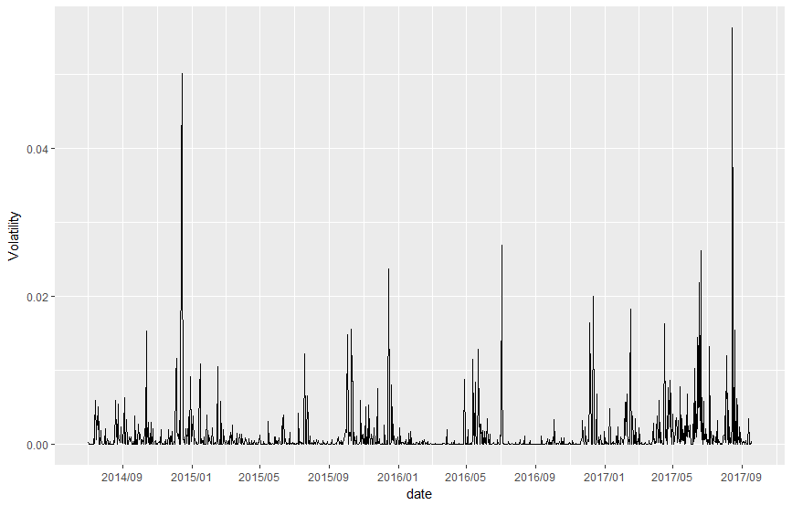

Figure 6 The squared ARIMA (2,0,2) residuals of CRIX returns

HW 5

**5.1 do a word cloud for Shakesspeare’s dramas. Romeo and Julia, Julius Caesar, Hamlet.**

rm(list = ls())

library(RCurl)

library(XML)

library(bitops)

library(stringr)

##Romeo and Juliet,Julius Caesar,hamlet

url=paste(c("http://publicliterature.org/pdf/2ws1610.pdf","http://publicliterature.org/pdf/2ws2410.pdf"," D:/研二/研二上/大数据与互联网金融/HW5 /hamlet.pdf ") )

abs=lapply(url, FUN = function(x) htmlParse(x, encoding = "Latin-1"))

clean_txt = function(x) {

cleantxt = xpathApply(x, "//body//text()

[not(ancestor :: script)][ not(ancestor :: style)]

[not(ancestor :: noscript)] " ,xmlValue)

cleantxt = paste(cleantxt, collapse="\n")

cleantxt = str_replace_all(cleantxt, "\n", " ")

cleantxt = str_replace_all(cleantxt, "\r", "")

cleantxt = str_replace_all(cleantxt, "\t", "")

cleantxt = str_replace_all(cleantxt, "<br>", "")

return(cleantxt)

}

cleantxt = lapply(abs,clean_txt)

vec_abs = unlist(cleantxt)

vec_abs

#Create a corpus & Term Document Matrix

library(tm)

library(SnowballC)

abs = Corpus(VectorSource(vec_abs))

abs_dtm = DocumentTermMatrix(abs, control = list(

stemming = TRUE, stopwords = TRUE, minWordLength = 3,

removeNumbers = TRUE, removePunctuation = TRUE))

dim(abs_dtm)

inspect(abs_dtm)

#Find the words that occur more than 3 times

findFreqTerms(abs_dtm, 3)

#Remove sparse terms

removeSparseTerms(abs_dtm, 0.5)

inspect(removeSparseTerms(abs_dtm, 0.5))

#wordcloud

library(ggplot2)

library(wordcloud)

freq = colSums(as.matrix(abs_dtm))

wf = data.frame(word=names(freq), freq=freq)

plot = ggplot(subset(wf, freq>100), aes(word, freq))

plot = plot + geom_bar(stat="identity")

plot = plot + theme(axis.text.x=element_text(angle=45, hjust=1))

plot

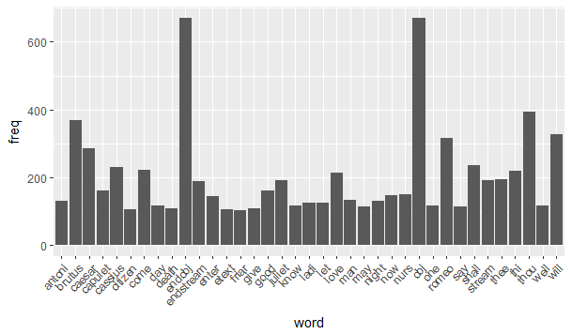

**Figure 1 : The display of Shakesspeare words whose frequency is above 100**

freq = colSums(as.matrix(abs_dtm))

dark2 = brewer.pal(8, "Dark2")

wordcloud(names(freq), freq, max.words=200, rot.per=0.1, colors=dark2)

#png("comment_cloud.png", width = 800, height = 800)

#wordcloud(names(freq),freq,scale= c(5, 1.5), min.freq = 1, max.words = 100,colors=dark2,family="myFont3",shape="circle")

dev.off()

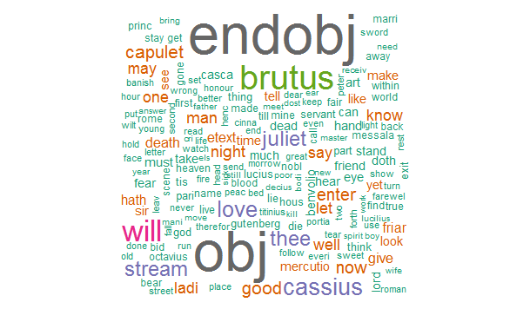

**Figure 2 : The word cloud of Shakesspeare words**

**5.2 calculate the histogram of words**

#histogram

hist(freq, col = "grey", breaks = 20,ylim = c(0, 5000), xlab = "words",main="Histogram of words")

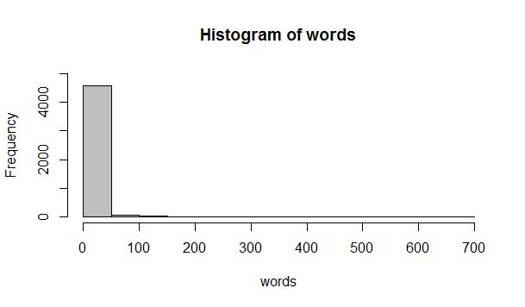

**Figure 3.1 : The histogram of Shakesspeare words**

hist(freq, col = "grey", breaks = 20,ylim = c(0, 20), xlab = "words",main="Histogram of words")

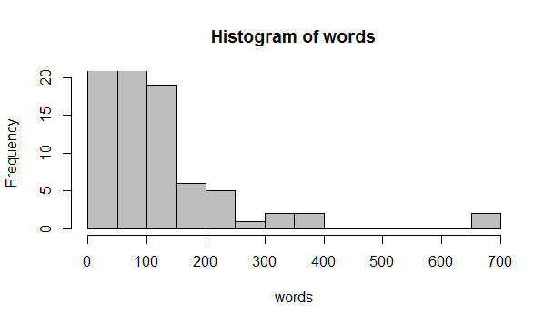

**Figure 3.2 : The histogram of Shakesspeare words**